**1.Modelo RF5_Indeg Apoio Controlo1 Reparacion2 DiqPriqCint X All var**.

***Instrucciones modelo***: **test size = 0.32 ; rd_state = 3**

***Variables indep select to fit***:

variables = [   'id', 'Indeg_RedeRisk_Cen',    'PC1_Distance_Pro',    'Degree_RedeTotFamil',

 '2_VarExp_Atri_Tabanca',  '1_VarExp_Moranca',  '9_VarExp_Atri_IndMelhorTecnDiqCint', '10_VarExp_Atri_MelhorTecnTubos',     'Area_bolanha',     'OutDeg_IntimAmigos_',  'OutDeg_RedeRisk_Cen',  'OutDeg_RedeConfianc'  ]

***Model performance (scores):***

Mean Squared Error: 4.0476

R^2 Score: 0.5904 (In Excel: R2 = 0.5974 ; y = 0.5371 X + 2.3106)

**Model tot:**

Mean Squared Error (MSE): 2.2713

Root Mean Squared Error (RMSE): 1.5071

Mean Absolute Error (MAE): 1.124

R^2 Score: 0.8139

Pearson Correlation: 0.9212

***Interactions***:

| **Interacción** | **Importancia** | **Dirección** |
| --- | --- | --- |
| 0 | (9_VarExp_Atri_IndMelhorTecnDiqCint, OutDeg_Re... | 1.795294 | 0.082924 |
| 1 | (OutDeg_IntimAmigos_, OutDeg_RedeConfianc) | 1.532069 | 0.213313 |
| 2 | (OutDeg_RedeRisk_Cen, OutDeg_RedeConfianc) | 1.451317 | 0.087738 |
| 3 | (2_VarExp_Atri_Tabanca, OutDeg_RedeConfianc) | 1.357519 | 0.030784 |
| 4 | (10_VarExp_Atri_MelhorTecnTubos, OutDeg_RedeCo... | 1.349040 | 0.106251 |
| 5 | (Indeg_RedeRisk_Cen, OutDeg_RedeConfianc) | 1.323947 | 0.031625 |
| 6 | (PC1_Distance_Pro, OutDeg_RedeConfianc) | 1.306435 | -0.033887 |
| 7 | (1_VarExp_Moranca, OutDeg_RedeConfianc) | 1.285561 | -0.030589 |
| 8 | (Degree_RedeTotFamil, OutDeg_RedeConfianc) | 1.261079 | 0.109837 |
| 9 | (Degree_RedeTotFamil, OutDeg_IntimAmigos_) | 1.192231 | 0.154172 |

***Key results****:*

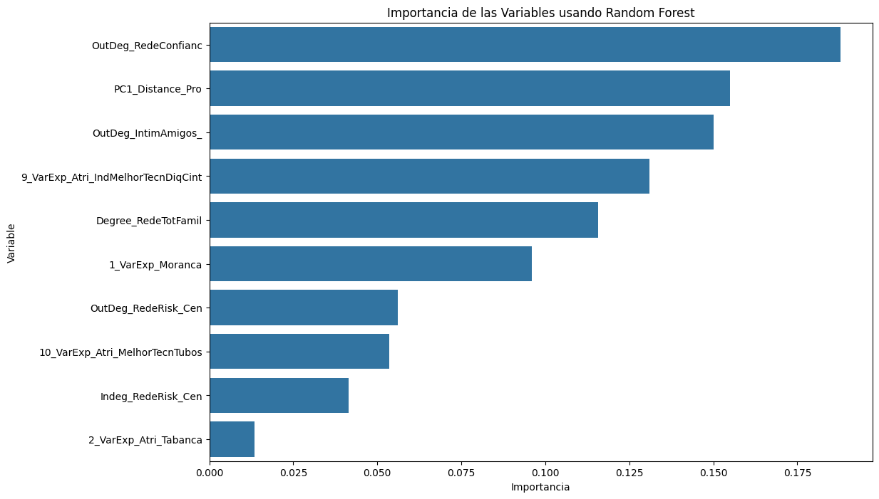

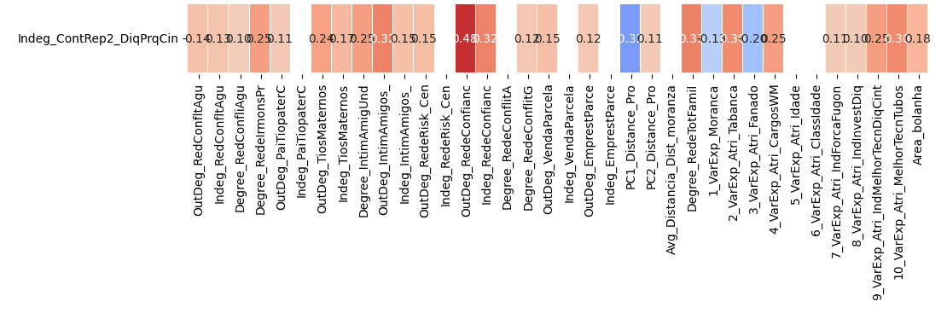

**2.Modelo RF5_Outdeg Apoio Controlo1 Reparacion2 DiqPriqCint X All var**.

***Instrucciones modelo***: **test size = 0.2 ; rd_state = 8**

***Variables indep select to fit***:

variables = [  'id',  'Indeg_IntimAmigos_',   'Indeg_RedeRisk_Cen',    'Indeg_RedeConfianc',

'PC1_Distance_Pro', 'Degree_RedeTotFamil', '1_VarExp_Moranca', '8_VarExp_Atri_IndInvestDiq','9_VarExp_Atri_IndMelhorTecnDiqCint', '10_VarExp_Atri_MelhorTecnTubos', 'Area_bolanha', 'OutDeg_RedeRisk_Cen', 'OutDeg_RedeConfianc' ]

***Model performance (scores):***

Mean Squared Error: 3.5769

R^2 Score: 0.9179 (In Excel: R2 = 0.9382 ; y = 0.8212 X + 0.3046 )

**Model tot:**

Mean Squared Error (MSE): 1.7674

Root Mean Squared Error (RMSE): 1.3295

Mean Absolute Error (MAE): 0.7597

R^2 Score: 0.9587

Pearson Correlation: 0.9838

***Interactions***:

|  | **Interacción** | **Importancia** | **Dirección** |
| --- | --- | --- | --- |
| 0 | (Indeg_RedeConfianc, 10_VarExp_Atri_MelhorTecn... | 6.912785 | 1.963595 |
| 1 | (Indeg_RedeConfianc, 2_VarExp_Atri_Tabanca) | 6.831214 | 2.001786 |
| 2 | (Indeg_RedeConfianc, 8_VarExp_Atri_IndInvestDiq) | 6.827293 | 2.002528 |
| 3 | (Indeg_RedeConfianc, 4_VarExp_Atri_CargosWM) | 6.819885 | 2.007748 |
| 4 | (Indeg_RedeRisk_Cen, Indeg_RedeConfianc) | 6.816476 | -0.053605 |
| 5 | (Indeg_RedeConfianc, OutDeg_RedeConfianc) | 6.807171 | 1.997587 |
| 6 | (Indeg_RedeConfianc, Degree_RedeTotFamil) | 6.801361 | 1.993064 |
| 7 | (Indeg_RedeConfianc, OutDeg_RedeRisk_Cen) | 6.791346 | 1.997245 |
| 8 | (Indeg_RedeConfianc, PC1_Distance_Pro) | 6.767699 | 1.996995 |
| 9 | (Indeg_IntimAmigos_, Indeg_RedeConfianc) | 6.761479 | 0.036014 |

***Key results****:*



